1. Potential Energy and Conservation of Energy

1. A force acting on a particle is conservative if:

A) its work is zero when the particle moves exactly once around any closed path

B) its work equals the change in the kinetic energy of the particle

C) it obeys Newton's second law

D) it obeys Newton's third law

E) it is not a frictional force

2. A nonconservative force:

A) violates Newton's second law

B) violates Newton's third law

C) cannot do any work

D) must be perpendicular to the velocity of the particle on which it acts

E) none of the above

3. The sum of the kinetic and potential energies of a system of objects is conserved:

A) only when no external force acts on the objects

B) only when the objects move along closed paths

C) only when the work done by the resultant external force is zero

D) always

E) none of the above

4. A force acting on a particle is conservative if:

A) its work equals the change in the kinetic energy of the particle

B) it obeys Newton's second law

C) it obeys Newton's third law

D) its work depends on the end points of the motion, not the path between

E) it is not a frictional force

5. Two particles interact by conservative forces and no other forces act. They complete round trips, ending at the points where they started. Over this trip:

A) the kinetic energy might have a different value at the beginning and end

B) the potential energy might have a different value at the beginning and end

C) the total mechanical energy might have a different value at the beginning and end

D) the total linear momentum might have different values at the beginning and end

E) none of the above

6. Two objects interact with each other and with no other objects. Initially object A has a speed of 5 m/s and object B has a speed of 10 m/s. In the course of their motion they return to their initial positions. Then A has a speed of 4 m/s and B has a speed of 7 m/s. We can conclude:

A) the potential energy changed from the beginning to the end of the trip

B) mechanical energy was increased by nonconservative forces

C) mechanical energy was decreased by nonconservative forces

D) mechanical energy was increased by conservative forces

E) mechanical energy was decreased by conservative forces

7. A good example of kinetic energy is provided by:

A) a wound-up clock spring

B) the raised weights of a grandfather's clock

C) a tornado

D) a gallon of gasoline

E) an automobile storage battery

8. No kinetic energy is possessed by:

A) a shooting star B) a rotating propeller on a moving airplane

C) a pendulum at the bottom of its swing D)an elevator standing at the fifth floor

E) a cyclone

9. The woundup spring of a clock possesses:

A) kinetic but no potential energy B)potential but no kinetic energy

C) both potential and kinetic energy D)neither potential nor kinetic energy

E) depends on the system of units

10. A body at rest is capable of doing work if:

A) the potential energy is positive

B) the potential energy is negative

C) it is free to move in such a way as to decrease its kinetic energy

D) it is free to move in such a way as to decrease the potential energy

E) it is free to move in such a way as to increase the potential energy

11. Which one of the following five quantities CANNOT be used as a unit of potential energy?

A) wattsecond B)gramcm/s2 C)joule D)kgm2/s2 E)ftlb

12. Suppose that the fundamental dimensions are taken to be: force (F), velocity (V) and time (T). The dimensions of potential energy are then:

A) F/T B) FVT C) FV/T D) F/T2 E) FV2/T2

13. The graphs below show the force acting on a particle as the particle moves along the positive *x* axis from the origin to *x* = *x*1. The force is parallel to the *x* axis and is conservative. The maxium magnitude *F*1 has the same value for all graphs. Rank the situations according to the change in the potential energy associated with the force, least (or most negative) to greatest (or most positive).

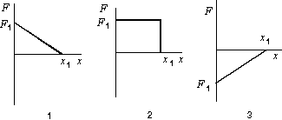

A) 1, 2, 3 B) 1, 3, 2 C) 2, 3, 1 D) 3, 2, 1 E) 2, 1, 3

14. A golf ball is struck by a golf club and falls on a green eight feet above the tee. The potential energy of the Earth-ball system is greatest:

A) just before the ball is struck B)just after the ball is struck

C) just after the ball lands on the green

D) when the ball comes to rest on the green

E) when the ball reaches the highest point in its flight

15. A ball is held at a height H above a floor. It is then released and falls to the floor. If air resistance can be ignored, which of the five graphs below correctly gives the mechanical energy E of the Earth-ball system as a function of the altitude *y* of the ball?

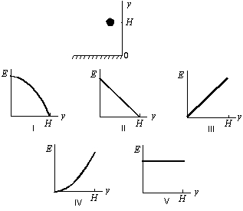

A) I B) II C) III D) IV E) V

16. A 6.0-kg block is released from rest 80 m above the ground. When it has fallen 60 m its kinetic energy is approximately:

A) 4800 J B)3500 J C)1200 J D)120 J E)60 J

17. A 2-kg block is thrown upward from a point 20 m above the Earth's surface. At what height above the Earth's surface will the gravitational potential energy of the Earth-block system have increased by 500 J?

A) 5 m B)25 m C)46 m D)70 m E)270 m

18. An elevator is rising at constant speed. Consider the following statements:

I. the upward cable force is constant

II. the kinetic energy of the elevator is constant

III. the gravitational potential energy of the Earth-elevator system is constant

IV. the acceleration of the elevator is zero

V. the mechanical energy of the Earth-elevator system is constant

A) all five are true B) only II and V are true

C) only IV and V are true D) only I, II, and III are true

E) only I, II, and IV are true

19. A projectile of mass 0.50 kg is fired with an initial speed of 10 m/s at an angle of 60 above the horizontal. The potential energy (relative to ground level) of the projectile at its highest point is:

A) 25 J B)18.75 J C)12.5 J D)6.25 J E)none of these

 20. For a block of mass *m* to slide without friction up the rise of height *h* shown, it must have a minimum initial speed of:



21. A 2.2-kg block starts from rest on a rough inclined plane that makes an angle of 25 with the horizontal. The coefficient of kinetic friction is 0.25. As the block goes 2.0 m down the plane, the mechanical energy of the Earth-block system changes by:

A) 0 B) –9.8 J C) 9.8 J D) –18 J E) 18 J

22. A simple pendulum consists of a 2.0 kg mass attached to a string. It is released from rest at X as shown. Its speed at the lowest point Y is:

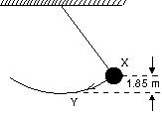

1. 0.90 m/s B) C)3.6 m/s D)6.0 m/s E)36 m/s

23. The long pendulum shown is drawn aside until the ball has risen 1.0 ft. It is then released from rest. The speed of the ball at its lowest position is:

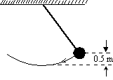

A) 3.1 m/s B) 4.2 m/s C) 5.8 m/s D) 20 m/s

E) cannot be determined unless the mass is known

24. A particle moves along the *x* axis under the influence of a stationary object. The force exerted on the particle is given by *F* = 8*x*3, where *F* is in newtons and *x* is in meters. If *x* = 0 is taken to be the zero of potential energy, then the potential energy in joules is given by:

A) 2*x*4 B) –2*x*4 C) 24*x*2 D) –24*x*2 E) 5 – 2*x*4

25. A 0.20-kg particle moves along the *x* axis under the influence of a stationary object. The potential energy is given by *U*(*x*) = 8*x*2 + 2*x*4, where *U* is in joules and *x* is in meters. If the particle has a speed of 5.0 m/s when it is at *x* = 1.0 m, its speed when it is at the origin is:

A) 0 B)2.5 m/s C)5.7 m/s D)7.9 m/s E)11 m/s

26. Which of the five graphs correctly shows the potential energy of a spring as a function of its elongation *x*?

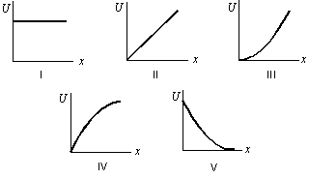

A) I B) II C) III D) IV E) V

27. A force of 10 N holds an ideal spring with a 20-N/m spring constant in compression. The potential energy stored in the spring is:

A) 0.5 J B) 2.5 J C) 5 J D) 10 J E) 200 J

28. An ideal spring is used to fire a 15.0-g block horizontally across a frictionless table top. The spring has a spring constant of 20 N/m and is initially compressed by 7.0 cm. The speed of the block as it leaves the spring is:

A) 0 B) 1.9 ×10–3 m/s C) 2.6 ×10–2 m/s

D) 0.39 m/s E) 2.6 m/s

29. A 0.50-kg block attached to an ideal spring with a spring constant of 80 N/m oscillates on a horizontal frictionless surface. The total mechanical energy is 0.12 J. The greatest extension of the spring from its equilibrium length is:

A) 1.5×10-3 m B) 3.0×10-3 m

C) 0.039 m D) 0.054 m E) 18 m

30. A 0.50-kg block attached to an ideal spring with a spring constant of 80 N/m oscillates on a horizontal frictionless surface. The total mechanical energy is 0.12 J. The greatest speed of the block is:

A) 0.15 m/s B)0.24 m/s C)0.49 m/s D)0.69 m/s E)1.46 m/s

31. A 0.50-kg block attached to an ideal spring with a spring constant of 80 N/m oscillates on a horizontal frictionless surface. When the spring is 4.0 cm shorter than its equilibrium length, the speed of the block is 0.50 m/s. The greatest speed of the block is:

A) 0.23 m/s B)0.32 m/s C)0.55 m/s D)0.78 m/s E)0.93 m/s

32. A 0.5-kg block slides along a horizontal frictionless surface at 2 m/s. It is brought to rest by compressing a very long spring of spring constant 800 N/m. The maximum spring compression is:

A) 0.1 cm B) 3 cm C) 5 cm D) 80 cm E) 80 m

33. A block of mass *m* is initially moving to the right on a horizontal frictionless surface at a speed *v*. It then compresses a spring of spring constant *k*. At the instant when the kinetic energy of the block is equal to the potential energy of the spring, the spring is compressed a distance of:

A)  B) (1/2)*mv*2 C) (1/4)*mv*2

D) *mv*2/4*k* E) 

34. A 700-N man jumps out of a window into a fire net 10 m below. The net stretches 2 m before bringing the man to rest and tossing him back into the air. The maximum potential energy of the net is:

A) 300 J B)710 J C)850 J D)7000 J E)8400 J

35. A toy cork gun contains a spring whose spring constant is 10.0 N/m. The spring is compressed 5 cm and then used to propel a 6.00 gram cork. The cork, however, sticks to the spring for 1.00 cm beyond its unstretched length before separation occurs. The muzzle velocity of this cork is:



A) 1.02 m/s B)1.41 m/s C)2.00 m/s D)2.04 m/s E)4.00 m/s

36. A small object of mass *m*, on the end of a light cord, is held horizontally at a distance *r* from a fixed support as shown. The object is then released. What is the tension in the cord when the object is at the lowest point of its swing?



A) *mg*/2 B) *mg* C) 2 *mg* D) 3 *mg* E) *mgr*

37. The string in the figure is 50 cm long. When the ball is released from rest, it will swing along the dotted arc. How fast, in m/s, will it be going at the lowest point in its swing?



A) 2.0 B) 2.2 C) 3.1 D) 4.4 E) 6.0

38. A block is released from rest at point P and slides along the frictionless track shown. At point Q, its speed is:

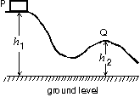

A)  B) 2*g*(*h*1 – *h*2) C) (*h*1 – *h*2)/2*g*

D)  E) (*h*1 – *h*2)2/2*g*

39. A small object of mass *m* starts at rest at the position shown and slides along the frictionless loop-the-loop track of radius *R*. What is the smallest value of *y* such that the object will slide without losing contact with the track?

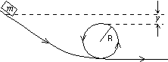

A) *R*/4 B) *R*/2 C) *R* D) 2*R* E) zero

40. A small object slides along the frictionless loop-the-loop with a diameter of 3 m. What minimum speed must it have at the top of the loop?

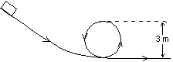

A) 1.9 m/s B)3.8 m/s C)5.4 m/s D)15 m/s E)29 m/s

41. A rectangular block is moving along a frictionless path when it encounters the circular loop as shown. The block passes points 1,2,3,4,1 before returning to the horizontal track. At point 3:

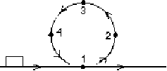

A) its mechanical energy is a minimum B) the forces on it are balanced

C) it is not accelerating D) its speed is a minimum

E) it experiences a net upward force

42. A ball of mass *m*, at one end of a string of length *L*, rotates in a vertical circle just fast enough to prevent the string from going slack at the top of the circle. The speed of the ball at the bottom of the circle is:





43. A particle is released from rest at the point *x* = *a* and moves along the *x* axis subject to the potential energy function *U*(*x*) shown. The particle:

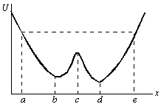

A) oscillates back and forth between *x* = *a* and *x* = *e*

B) oscillates back and forth between *x* = *a* and *x* = *c*

C) moves to infinity at varying speed

D) moves to *x* = *e* where it remains at rest

E) moves to *x* = *b* where it remains at rest

44. The potential energy of a particle moving along the *x* axis is given by *U*(*x*) = 8*x*2 + 2*x*4, where *U* is in joules and *x* is in meters. If the total mechanical energy is 9.0 J, the limits of motion are:

A) –0.96 m; +0.96 m B) –2.2 m; +2.2 m

C) –1.6 m; +1.6 m D) –0.96 m; +2.2 m E) –0.96 m; +1.6 m

45. The potential energy of a 0.20 kg particle moving along the *x* axis is given by *U*(*x*) = 8*x*2 + 2*x*4, where *U* is in joules and *x* is in meters. When the particle is at *x* = 1.0 m it is traveling in the positive *x* direction with a speed of 5.0 m/s. It next stops momentarily to turn around at *x* =

A) 0 B)–1.1 m C)1.1 m D)–2.3 m E)2.3 m

46. Given a potential energy function *U*(*x*), the corresponding force  is in the positive *x* direction if:

A) *U* is positive B) *U* is negative

C) *U* is an increasing function of *x*

D) *U* is a decreasing function of *x*

E) it is impossible to obtain the direction of  from *U*

47. As a particle moves along the *x* axis it is acted by a conservative force. The potential energy is shown below as a function of the coordinate *x* of the particle. Rank the labeled regions according to the magnitude of the force, least to greatest.

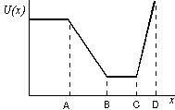

A) AB, BC, CD B) AB, CD, BC C) BC, CD, AB

D) BC, AB, CD E) CD, BC, AB

48. The first graph shows the potential energy *U*(*x*) for a particle moving on the *x* axis. Which of the following five graphs correctly gives the force *F* exerted on the particle?

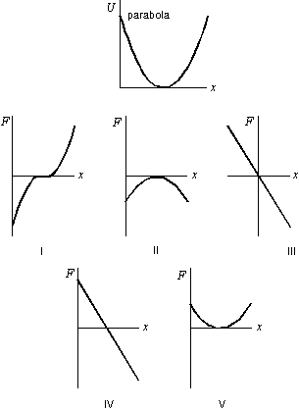

A) I B) II C) III D) IV E) V

49. The diagram shows a plot of the potential energy as a function of *x* for a particle moving along the *x* axis. The points of stable equilibrium are:

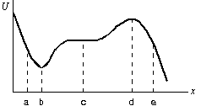

A) only a B)only b C)only c D)only d E)b and d

50. The diagram shows a plot of the potential energy as a function of *x* for a particle moving along the *x* axis. The points of unstable equilibrium are:

A) only a B)only b C)only c D)only d E)b and d

51. The diagram shows a plot of the potential energy as a function of *x* for a particle moving along the *x* axis. The points of neutral equilibrium are:

A) only a B)only b C)only c D)only d E)b and d

52. The potential energy of a body of mass m is given by *U* = –*mgx* + 1/2*kx*2. The corresponding force is:

A) –*mgx*2/2 + *kx*3/6 B) *mgx*2/2 – *kx*3/6

C) –*mg* + *kx*/2 D) –*mg* + *kx* E) *mg* – *kx*

53. The potential energy of a 0.20-kg particle moving along the x axis is given by *U*(*x*) = 8*x*2 – 2*x*4, where *U* is in joules and *x* is in meters. When the particle is at *x* = 1.0 m its acceleration is:

A) 0 B)–8 m/s2 C)8 m/s2 D)–40 m/s2 E)40 m/s2

54. The potential energy for the interaction between the two atoms in a diatomic molecule is *U* = *A*/*x*12 – B/*x*6, where *A* and *B* are constants and *x* is the interatomic distance. The force that one atom exerts on the other is:



A) 12*A*/*x*13 – 6*B*/*x*7 B) –13*A*/*x*13 + 7*B*/*x*7 C) –11*A*/*x*11 + 5*B*/*x*5

D) 72*A*/*x*12 – 72*B*/*x*6 E) *A*/*x*13 – *B*/*x*7

55. The internal energy of a system consisting of a thrown ball, Earth, and the air is most closely associated with:

A) the gravitational interaction of the Earth and the ball

B) the kinetic energy of the ball as a whole

C) motions of the individual particles within the ball

D) motions of individual particles within the ball and the air

E) the kinetic energy of the Earth as a whole

56. Three identical blocks move either on a horizontal surface, up a plane, or down a plane, as shown below. They all start with the same speed and continue to move until brought to rest by friction. Rank the three situations according to the mechanical energy dissipated by friction, least to greatest.

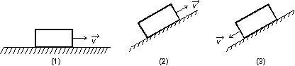

A) The same for all cases

B) 1, 2, 3 C)1, then 2 and 3 tie D)3, 2, 1 E)2, 1, 3

57. Objects A and B interact with each other via both conservative and nonconservative forces. Let *KA* and *KB* be the kinetic energies, *U* be the potential energy, and *E*int be the internal energy. If no external agent does work on the objects then:

A) *KA* + *U* is conserved B) *KA* + *U* + *E*int is conserved

C) *KA* + *KB* + *E*int is conserved D) *KA* + *KB* + *U* is conserved

E) *KA* + *KB* + *U* + *E*int is conserved

58. A block slides across a rough horizontal table top. The work done by friction changes:

A) only the kinetic energy B) only the potential energy

C) only the internal energy D) only the kinetic and potential energies

E) only the kinetic and internal energies

59. A 25-g ball is released from rest 80 m above the surface of the Earth. Just before it hits the surface its speed is 20 m/s. During the fall the internal energy of the ball and air changed by:

A) +15 J B) –15 J C) +5 J D) –5 J E) 0

60. A 5 kg projectile is fired over level ground with a velocity of 200 m/s at an angle of 25 above the horizontal. Just before it hits the ground its speed is 150 m/s. Over the entire trip the change in the internal energy of the projectile and air is:

A) +19,000 J B) –19,000 J C) +44,000 J

D) –44,000 J E) 0

61. A 0.75-kg block slides on a rough horizontal table top. Just before it hits a horizontal ideal spring its speed is 3.5 m/s. It hits the spring and compresses it 5.7 cm before coming to rest. If the spring constant is 1200 N/m, the internal energy of the block and the table top must have increased by:

A) 0 B) 1.9 J C) 2.6 J D) 4.6 J E) 6.5 J